Paola Pergami, MD, PhD

Pediatric Stroke and Neurorehabilitation
MD, University of Pavia, Italy, 1989
PhD, University of Milan, Italy, 2000
Residency Pediatrics and Neurology, WVU 2007
Fellowship, Child Neurology, UPMC, Pittsburgh, PA
Research Interest: Pediatric stroke; Motor learning/rehabilitation; Outcome prediction.
_____________________________________________________________________

1. Advanced MRI imaging for outcome prediction in pediatric stroke
Stroke is a significant cause of childhood mortality, morbidity and long-term disability but is frequently undiagnosed, particularly in the neonates. We are interested in identifying biomarker for early diagnosis and quantification of ischemic brain injury in neonates and children. We are using advanced imaging techniques including quantitative measures of white matter damage and resting state functional connectivity. We want to understand the role of white matter lesions in the development of motor and cognitive delay in children with ischemic brain injury.
We also want to explore how rehabilitation can modify abnormal brain connectivity from stroke. We are also trying to identify changes in brain connectivity that results from aggressive and early rehabilitation intervention and are related to improved outcome and brain plasticity mechanisms.

2. Gait development in children

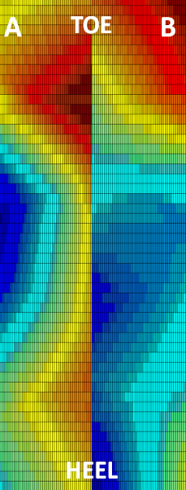
In collaboration with the Department of Engineering, we are working to develop a system for characterization and monitoring of motor function in children with stroke. These include characterization of gait parameters during early development, as well as quantification of hand dexterity in normally developing children and in children with stroke. We are testing use of low-cost technologies, like pressure gauges and cell-phone accelerometers for home based monitoring of rehabilitation intervention.
Schematic of pressure foot data, after acquisition and processing in Matlab. A) Left foot pressure distribution for normal gait, 3 years old subject. B) Left foot pressure distribution for pathological gait, 3 years old subject. Red indicates regions of high pressure; regions of low pressure are blue.

3. Role of Inflammation in Pediatric Stroke

We are investigating the role of inflammation in neonatal ischemic brain injury, specifically Hypoxic Ischemic Encephalopathy (HIE) and Acute Ischemic Stroke (AIS). to identify differences in absolute neutrophil and lymphocyte counts, and neutrophil/lymphocyte ratio (NLR) between neonates with ischemic brain injury and healthy, age-matched controls. We will also determine if these differences can be used as potential diagnostic markers for neurological long-term outcome.
After sufficient clinical data has been obtained, the results will be translated into a neonatal HIE animal model, where the role of infection and inflammation in the pathogenesis of ischemic lesions can be further investigated.

Selected Publications:
- E. Pistilli, T. Rice, P. Pergami, M.B. Mandich. Non-invasive serial casting to treat idiopathic toe walking in an 18-month old child. Accepted for publication NeuroRehabilitation 2013
- A. Smith, J. Carpenter, P. Pergami. Nocturnal Headaches and Pulsatile Cranial Mass: The Tip of an Iceberg. Pediatric Neurology 2013 49:358-360.
- A. Moeck, P. Pergami. A Pediatric Patient with Headache and Neck Stiffness. Neurology; 2013, 81(13) e-101. Selected for Neurology cover picture, September 24 2013 issue.
- P. Pergami, N. Seemaladinne, A.B. Billing. Validating the Use of a Computer Application as Test of Motor Function in Children and Adults. Neurorehabilitation, 2012 (1-9).
- P. Pergami, N. Seemaladinne, P. Martone. Development of a New Application for Motor Control Experiments: Possible Telemedicine Application as Test of Motor Function. Neuroinformatics; 2012, Jan 28.
- P. Pergami, N. Seemaladinne. Stroke in Children: Need for Increased Awareness. WV Journal of Medicine, Nov-Dec 2012.
- C. Buetefisch, B. Hines, L. Shuster, P. Pergami, A. Mathes. Motor demand dependent improvement in accuracy following low-frequency transcranial magnetic stimulation of left motor cortex. J Neurophysiol, 2011 Jul 6:325-41.
- P. Pergami, L. Abraham. Neonatal Cerebral Sinovenous Thrombosis (CSVT): to treat or not to treat? A retrospective study. J Child Neurol, 2011 Jul, 26(7):844-50.

